**Lincoln Community Larder**

**Business Plan 2024/25**

This plan complements our Strategic Plan 2024/27 and sets out, in a more detailed manner, how we will undertake the operational and practical elements of that plan. Importantly, it identifies the key tasks and activities, the individuals who have agreed to lead that task and when we hope to complete it.

Moving forwards we will refresh this plan every year. The Chair will maintain the plan, map progress and report formally to board mid -year and end of year, but any areas that become problematic can be considered at any time.

|  |  |  |  |  |  |  |  |
| --- | --- | --- | --- | --- | --- | --- | --- |
| ***Index*** | ***Activity*** | ***Strategic Plan reference*** | ***Lead person*** | ***Completion by*** | ***Notes*** | ***Status***  ***(red = in exception, Amber = behind time or some issues, Green = On track***  ***Blue = delivered***  ***Clear = yet to start*** | |
| 1 |  |  |  |  |  | |  |
| 2 | ***Food Sourcing*** |  |  |  |  | |  |
| 3 | Seek best value combined with ease of delivery – currently key suppliers being Sainsbury and Bookers | 1 a) | Larder Coordinator | Ongoing |  | |  |
| 4 | Manage purchase of supplies, tracking budget in collaboration with the Treasurer to ensure cash flow is managed responsibly | 4 A  4 B t) | Larder Coordinator | Ongoing - monthly |  | |  |
| 5 |  |  |  |  |  | |  |
| 6 | ***Food Storage and Packing*** |  |  |  |  | |  |
| 7 | Manage warehouse operation on an ongoing basis coordinating activity to ensure deliveries received and orders prepared. | 1 a) | Warehouse coordinator | Ongoing |  | |  |
| 8 |  |  |  |  |  | |  |
| 9 |  |  |  |  |  | |  |
| 10 | ***Food Distribution*** |  |  |  |  | |  |
| 11 | Maintaining contact with key larder hub managers and partner bodies in relation to operational matters | 3 f) | Larder Coordinator | Regular report to Trustee Board |  | |  |
| 12 | Monitor demand levels and apprise Trustee Board to enable financial and demand planning | 4 A | Larder Coordinator | Regular report to Trustee Board |  | |  |
| 13 |  |  |  |  |  | |  |
| 14 | ***Volunteers*** |  |  |  |  | |  |
| 15 | Maintain up to date register of volunteers | 4 B h) l) | Volunteer coordinator | Regular report to Trustee Board |  | |  |
| 15 | Sustain contacts with volunteer agencies | 4 B l) | Volunteer coordinator | To be agreed |  | |  |
| 17 |  |  |  |  |  | |  |
| 18 | Identify small range of volunteer roles with different job specifications/time demands | 4 B h) l) | Chair/Volunteer coordinator | To be agreed | Aim to maximise usage of volunteers coming forwards and plan to meet our needs for current workloads | |  |
| 19 | Seek supermarket lead and team for Autumn campaign | 4 A h) | Chair/Volunteer coordinator | To be agreed | Considering supermarket visits to boost customer donations – Probable date Spring 2025 | |  |
| 20 |  |  |  |  |  | |  |
| 21 | ***Fundraising*** |  |  |  |  | |  |
| 22 | Proactively seek funding opportunities | 4 A f) g) | Finance sub-group (Chair/Treasurer/TT) | ongoing |  | |  |
| 23 | Building ‘on the shelf’ projects to bid for - being agile | 4 A f) g) | Finance sub-group (Chair/Treasurer/TT) | ongoing |  | |  |
| 24 | Proactively seek funding opportunities | 4 A f) g) | Finance sub-group (Chair/Treasurer/TT) | ongoing |  | |  |
| 25 |  |  |  |  |  | |  |
| 26 |  |  |  |  |  | |  |
| 27 |  |  |  |  |  | |  |
| 28 | ***Food Donations*** |  |  |  |  | |  |
| 29 | Harvest festival management | 4 A h) | Harvest coordinator | ongoing |  | |  |
| 30 | Supermarket static point collections | 4 A h) | Larder coordinator | TBA | Need to map current activity - Chair | |  |
| 31 | Linking in with planned events (Santa run etc) – Chair to contact relevant body | 4 A h) | Chair | November 2024 |  | |  |
| 32 | Supermarket team visits – develop Autumn campaign | 4 A h) | Chair/Volunteer coordinator/Larder coordinator – seek volunteer leader | November 2024 |  | |  |
| 33 |  |  |  |  |  | |  |
| 34 |  |  |  |  |  | |  |
| 35 |  |  |  |  |  | |  |
| 36 | ***Communications*** |  |  |  |  | |  |
| 37 | Social media and proactive comms - | 4 C G | Communications officer - Amy Zwaan | Comms lead to provide regular activity reports to the Trustee Board |  | |  |
| 38 | Newsletter - | 4 B l)  4G  4C | Chair | Three per year – Spring, Autumn, Xmas | Need to do one soon! | |  |
| 39 | Build regular contact with Outreach leaders | 4 B l)  4G | Chair |  |  | |  |
| 40 | Website management – rebuild on new platform/ private members area for docs/minutes etc? | 4C | Chair/Vice Chair | Live by March 2025 |  | |  |
| 41 | IT system for referrals – maintain with ACTs Trust | 5 | Chair/Vice Chair | Ongoing |  | |  |
| 42 | ***Relationship management and networking*** |  |  |  |  | |  |
| 43 | Represent Larder at Greater Lincolnshire Food Partnership | 4G | Chair | Report activity regularly to Board | Chair joining Board of partnership | |  |
| 44 | Get tips re available sources of finance/support | 4G | All | Ongoing | Keep our ears open and pass tips to Finance sub-group | |  |
| 45 | Build better relationship with Coop as partner with strong potential for future | 4G | Chair |  | Chair meets Coop rep at G Lincs Food Partnership | |  |
| 46 |  |  |  |  |  | |  |
| 47 |  |  |  |  |  | |  |
| 48 |  |  |  |  |  | |  |
| 49 | ***Financial Management*** |  |  |  |  | |  |
| 50 | Manage day to day financial records and bank accounts | 4 B t) | Treasurer | Report activity regularly to Board |  | |  |
| 51 | Manage Restricted (Investment) Reserve and achieve best returns commensurate with risk appetite set by Board | 4 B t) | Chair/ Treasurer/ TT | August 2024 | Agreed sum notice given and accounts set up. On target for funds to be moved  (Lloyds + Mkt Harborough Bdg Soc) | |  |
| 52 | Quarterly review of rates being achieved with investment reserve to ensure sensible returns | 4 B t) | Chair/ Treasurer/ TT | Report activity regularly to Board |  | |  |
| 53 | Manage financial plan and budget for the year | 4 B t) | Chair/ Treasurer/ TT | Treasurer to report progress at each Trustee Board | See Appendix A (detailed financial plan) | |  |
|  |  |  |  |  |  | |  |
| 54 | ***Buildings, Estate and Equipment*** |  |  |  |  | |  |
| 55 | New leases | 4F | Chair/ Treasurer/ TT |  | Need to formalise with YMCA and sign off | |  |
| 56 | Refurb of RL | 4D | Chair/Larder coordinator | Largely complete | Formal opening held June 2024 | |  |
| 57 | Maintain IT equipment and software |  | Chair/Larder coordinator |  | Pretty much up to date | |  |
| 58 |  |  |  |  |  | |  |
| 59 |  |  |  |  |  | |  |
| 60 | ***Governance*** |  |  |  |  | |  |
| 61 | Lead and run meetings | 4B | Chair |  |  | |  |
| 62 | Maintain efficient and effective records of meetings/actions set and Larder Trustee Board correspondence and notes | 4B | Secretary | Ongoing |  | |  |
| 63 | Maintain agreed schedule of performance data and provide reports to the Trustee Board – how often and what | 5 | Vice Chair | Under development Board already received initial version – June 2024 | See Appendix B (schedule of data to be collected) – Need to add Appendix later | |  |
| 64 |  |  |  |  |  | |  |
| 65 |  |  |  |  |  | |  |
|  |  |  |  |  |  | |  |

**APPENDIX A – FINANCIAL PLAN AND BUDGET 2024/25**

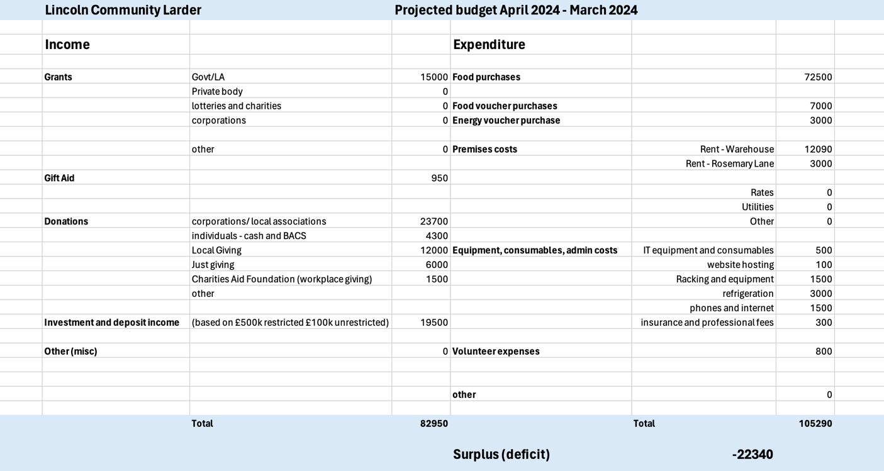

**APPENDIX B – SCHEDULE OF PERFORMANCE DATA TO BE COLLECTED FOR THE BOARD OF TRUSTEES**

TO BE DEVELOPED